The Definitive Guide to Calypso Printout Header Variables

In Calypso, there are two basic types of printout header variables. These variables are either pre-defined or user defined.

Each variable has its own distinctive label or keyword and its coded name. The label or keyword is what would appear to the user or operator and the coded name would be used when accessing this variable.

For example, to access the measurement plan name, the label is **Meas. Plan Name** and the variable is **planid**.

**Pre-defined Variables:** When using the predefined Calypso header variables, they fall into four categories: System, Edit, Start and Other.

**System:** System variables are either set by the Computer, the CMM or Calypso. They are the following:

# CMM No. ............................................... dmesn

**Time ...................................................... time**

**From ...................................................... nrpgs**

**Date ....................................................... date**

**Meas. Plan Name .................................. planid**

**Software Revision .................................. dmeswv**

**Department: ........................................... vda_departm**

**Software ................................................ dmeswi**

**Telephone/Fax: ...................................... vda_phone**

**No: ......................................................... vda_number**

**Controller ............................................... Controller**

**Page ...................................................... actpgnr**

**CMM Type ............................................. dmeid**

**Operator ................................................ operid**

**Run ........................................................ measRun**

**Edit:** Edit variables are used when reporting data that does not change from run to run. For example, workpiece rev. The programmer can change the data stored in this variable when making a program change. Entering data for these variables are usually done through this pulldown menu: **Resources, Printout Header Parameters.**

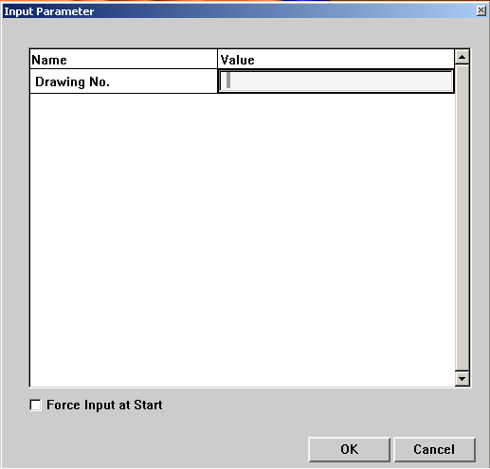

The list of edit variables are:

# Clamp No. ............................................. clmpsn

**Comment: .............................................. vda_remark**

**Clamp ID ............................................... clmpid**

**Workpiece Name ................................... partid**

# Previous Operation ................................ prevop

**Workpiece Ser. No. ................................ partsn**

**Meas. Plan Comment ............................ partcomment**

**Subject Number: .................................... vda_subjno**

**Fixture No: ............................................. fixtsn**

**Name: .................................................... vda_name**

**Version: ................................................. vda_version**

**Fixture ID ............................................... fixtid**

**Workpiece Rev. ..................................... partrv**

**Audit-No.: ............................................... vda_auditno**

**Drawing No. ........................................... drawingno**

## Start: Start variables are used when the operator needs to key in data from run to run. By using either of these two methods, operators can input data. Clicking on the Printout Header data icon in the run menu or turning on Forced input at start in the Printout Header Parameters window.

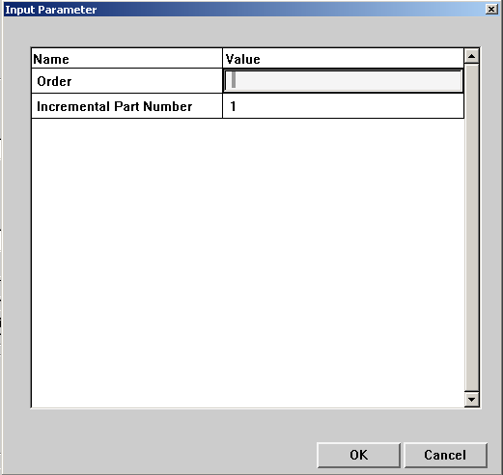

## Start variables consist of the following:

### StartComment ...................................... startcomment

**Comment: .............................................. vda_remark**

**Test ID ................................................... procid**

**Lot ID ..................................................... lotid**

**Part Number .......................................... partnbLong**

**Subject Number: .................................... vda_subjno**

**Name: .................................................... vda_name**

**Process Plan ......................................... mfgdev**

**Order ..................................................... order**

**Incremental Part Number....................... partnbinc**

**Version: ................................................. vda_version**

**Audit-No:................................................ vda_auditno**

**Tool ........................................................ tooldf**

**Signature: .............................................. vda_signature**

**Other:** Calypso supplies the data for these variables. For example, Date Of Revision. This is the date the program was last stored. Other variables are as follows:

### Changed By (operator) .......................... changeoper

**Creation Of Software Rev. ..................... creationswi**

**Date Of Revision ................................... changedate**

**Created By (operator) ............................ produceoper**

**Date Of Creation .................................... creationdate**

**Creation Of CMM Type .......................... creationdme**

**User defined Variables:** Can be used when a variable does not exist in the pre-defined list. These variables are defined in one of these two files: userfields.txt or userfileds.ini. They reside in this directory: \Calypso\opt\om\protform\

**Userfields.txt:** These variables can only be used with a standard input box.

Each pre-define variable has three components. The ID or variable, the designation or label, and the display control. For example, **u_sernum,Serial Number,RE**

**ID:** When defining a variable, it must start with a “u_” first. Ex: **u_sernum**.

**Designation:** Is a label or keyword, which appears to the user.

**Display Control** This sets the type of variable. Similar to the Pre-defined variables, **R** signifies the variable will reside in the list of Start variables and **E** in the list of Edit variables. **RE** appears in both lists.

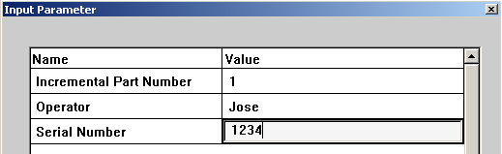

**Userfields.ini:** These variables can use a standard input box, a pull down menu or both. The following structure has to be followed when defining these variables.

The file consists of individual sections, each of which is introduced by a line with the section name in square brackets.

**Fieldnames:** In this section, the user defines the list of variable names to be used in the printout header. Similar to the userfileds.txt file, these variables must start with a “u_”.

**Input Field:** For each of the variable defined in the Fieldnames section, there is a separate section with this variable name in brackets [ ].

Each section that represents an input field, a selection list or a combo box contains lines with the following options:

**name:** Is a label or keyword, which appears to the user in the dialog box.

**editMode:** This filed has a true or false selection. If editMode is true, then it will appear in the **Resources, Report Header Parameters** menu selection. This is the same as the **,E** selection in the userfields.txt file.

**runMode:** This filed has a true or false selection. If runMode is true, then it will appear at **CNC Start** menu selection. This is the same as the **,R** selection in the userfields.txt file.

**selectiveList:** This filed has a true or false selection. If selectiveList is true, input will be made through a list of user defined choices. If false, there will be a combo box for keyboard input.

**selectiveListValues:** This is where the user defines the name of the list of input choices for this particular variable.

**editable:** This filed has a true or false selection. If editable is true, the user has a choice from the items in the selective list or can use the keyboard to input data for this variable.

If false, the user can only make a choice from the selective list.

**defaultValue:** The user can specify what the default value for this variable is. If using a selective list, you can specify which item from the list is the default value. If the variable uses a combo box, the default value will appear in the input window.

Examples

u_field1,FELD 1,RE

u_field2,FELD 2,R

u_field3,FELD 3,E

**Selective List Data:** For each of the variables that are defined as a selective list, there is a separate section for each list of data for this variable. The selective list variable name is within brackets [ ].

**Example of a Userfields.ini file.**

[Fieldnames]

u_shift

u_oper

u_sernum

[u_shift]

name=Shift

editMode=false

runMode=true

selectiveList=true

selectiveListValues=u_shift_data

editable=false

defaultValue=1

[u_oper]

name=Operator

editMode=false

runMode=true

selectiveList=true

selectiveListValues=u_oper_data

editable=false

defaultValue=1

[u_sernum]

name=Serial Number

editMode=false

runMode=true

selectiveList=false

editable=true

defaultValue=000001

[u_shift_data]

1=First

2=Second

3=Third

[u_oper_data]

1=Jim S

2=Mark F

3=Jerry L

4=Stacy P

5=Willy G

6=Mark B

7=Tom S

8=Joe G

**PCM use with header variables:** When using PCM, there are two commands for printout header variables.

**getRecordHead:** This command will access data stored in a printout header variable.

Ex: **MR=getRecordHead(“measRun”)**. This will store the run list into a local variable MR. The run list will be either All Characteristics, Current Selection or a Mini Plan name.

**setRecordHead:** This command will store data stored in a printout header variable.

Ex: **setRecordHead(”tooldf”,PALLET)**. This will store data from the local variable PALLET. A user may also hard code a value. Instead of using the variable PALLET, the user will type in what they would like to store in the header variable tooldf.