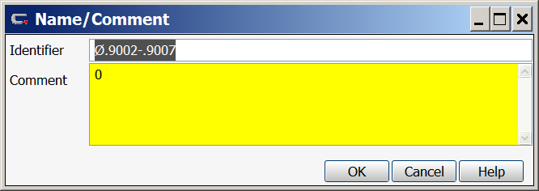
Right Click in the Comment text box and select formula.
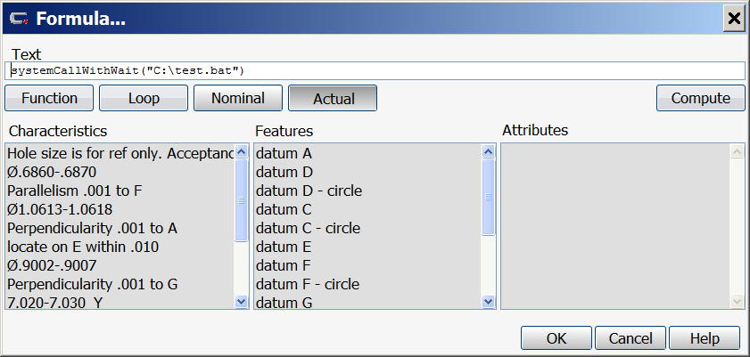
Use the systemCallWithWait() command. Since this command will only work with executable or batch files, you will need to create a batch file to open your picture file. The path to the batch file is inside the parentheses.
Your batch file will look something like this:
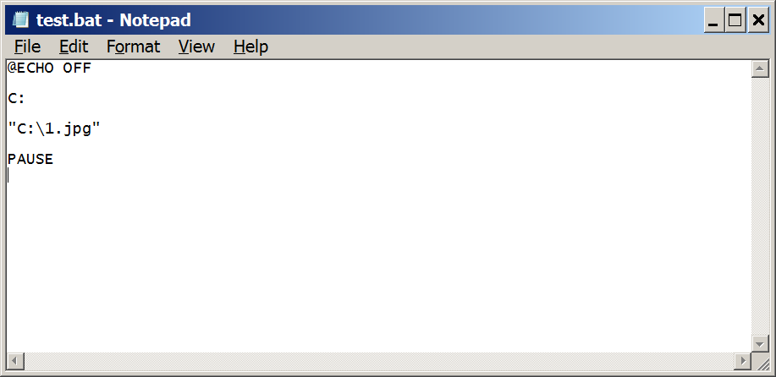
Inside the quotes is the path to the file you want to open.

