How to Evaluate True Position of a Slot with MMC
In Calypso

Example:

C
B
-A-
Slot Width 8.0 ± 0.1
0.1 M A B C
108°

Measure:

- Top Plane (Datum A)
- Center Circle (Datum B)
- Symmetry Point in Left Slot (Datum C)
- Left side of slot to evaluate as a line or plane
- Right side of slot to evaluate as a line or plane

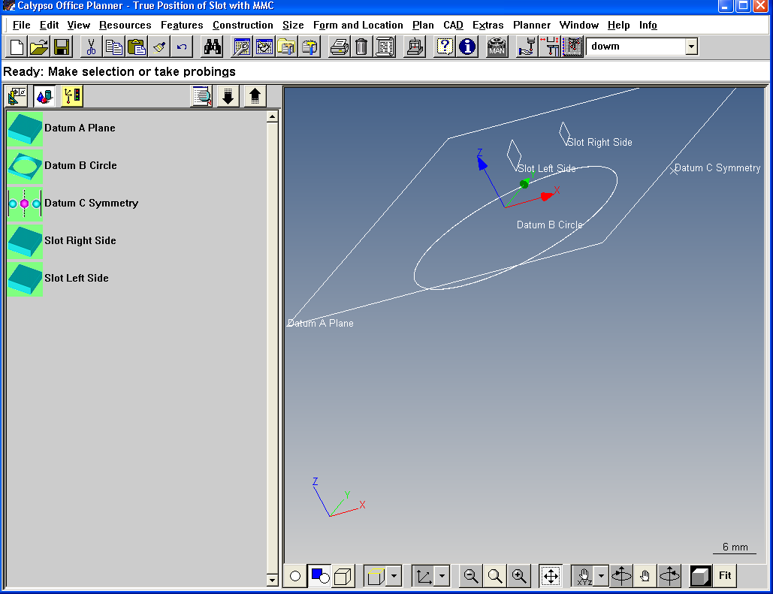
Create Constructions:

- CONSTRUCTION>PERPENDICULAR between Left and Right side of slot.
- FEATURES>POINT. Open the point and choose NOMINAL DEFINITION>RECALL. Select the Perpendicular from above.
- FEATURES>CIRCLE. Open the circle and choose NOMINAL DEFINITION>THEORETICAL FEATURE.
- In the X ACTUAL field of the circle, right click and choose formula. Enter the formula getActual(“Point1”).x assuming the constructed point is named “Point1”.
- In the Y ACTUAL field, right click and choose formula. Enter the formula getActual(“Point1”).y assuming the constructed point is named “Point1”.
- In the Z ACTUAL field, right click and choose formula. Enter the formula getActual(“Point1”).z assuming the constructed point is named “Point1”.
- In the Diameter ACTUAL field, right click and choose formula. Enter the formula getActual(“Perpendicular1”).len assuming the constructed perpendicular is called “Perpendicular1”.
- Enter appropriate NOMINALS for the slot center. Note that the nominals do not need to be perfect – the true position nominals will take care of that.

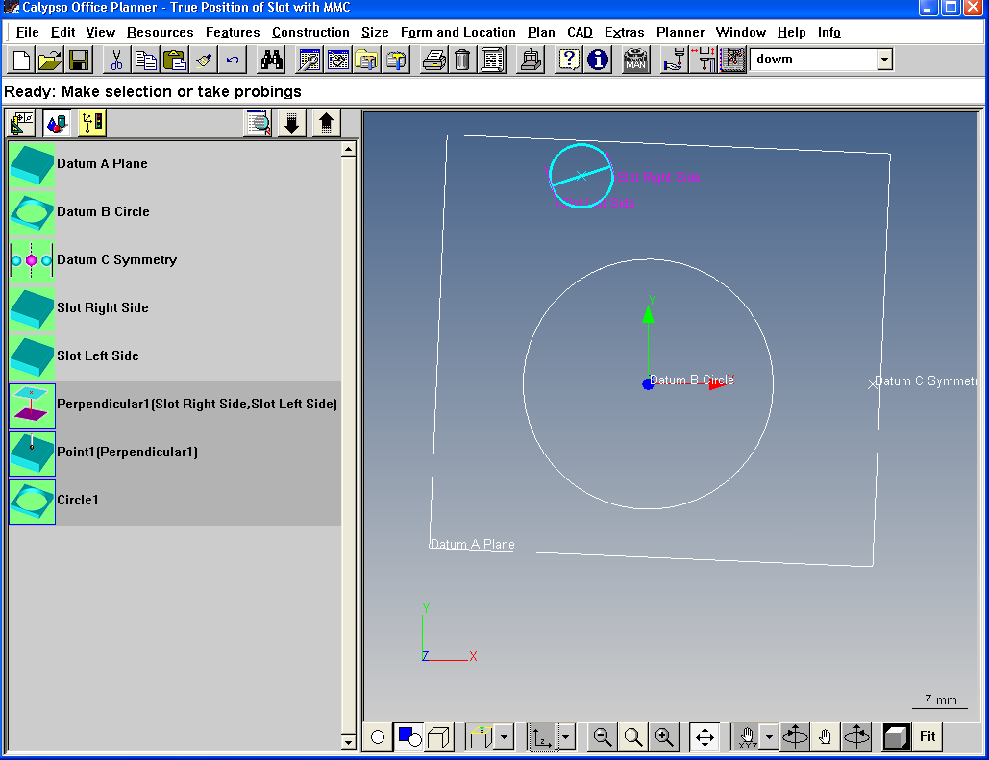

Create Characteristic:

- FORM AND LOCATION>TRUE POSITION
- Enter the Theoretical Circle as the Feature. Enter the top plane, center circle, and slot symmetry into the window as the Datums.
- Click the SPECIAL BUTTON in the True Position window and Rotate about the Z axis the basic dimension angle of 108°.
- In the True Position window, change the SHAPE OF ZONE to ONLY Y.
- Edit Y basic dimension to Zero if it is not Zero already.
- Change RFS to MMC in the dropdown for the Circle Feature and ensure the characteristic nominals and tolerances are correct for the Circle diameter.
- Enter your True Position tolerance from the Print.
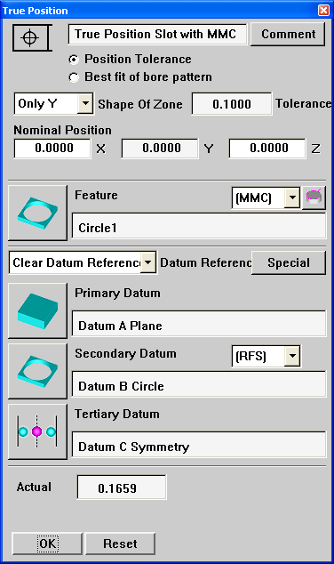
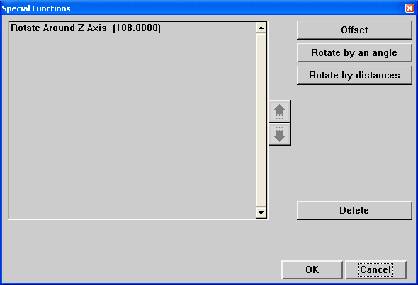

Enter your Basic Rotation angle here. This rotates the coordinate system created by the datums so the slot is “lined up” with one axis. Evaluation with a “slab” shaped zone in Y is now possible.
Click MMC on here and Click the Diameter button to enter the Nominal and Tolerances so MMC bonus can be calculated.
Change the Zone shape from “Diametral” to “Only Y” to match the True Position Callout.
Make sure this Value is Zero.
Understand Report:

- Below is what is a graphic describing what is set up in the True Position Characteristic.
C
B
X
Y
Slot Width 8.0 ± 0.1
0.1 M A B C
108°
Slab tolerance in Y with thickness of 0.1 at MMC
Rotated Coordinate System by 108° from Datums
- Below is the Calypso Custom Printout with Additional Position Result turned on.

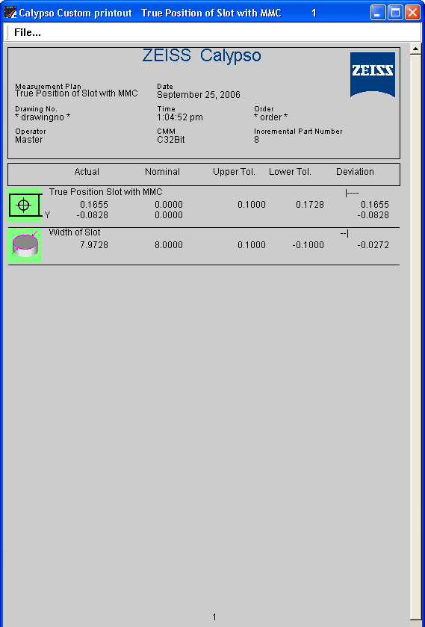

- This Report indicates that the Slot is in Tolerance, but shifted to the “right” by 0.0828mm in the rotated coordinate system. Notice that the tolerance WITH BONUS, 0.1728mm, is shown in the “Lower Tol.” Column.

