What is the relationship between concentricity and runout? I keep seeing this question come up on the net and very few places seem to give the correct answer. Usually the discussion gets bogged down and confused by people adding in circularity and/or parallelism of 3D objects and somehow people end up saying that they are numerically equivalent or no conversion is possible.

The correct answer is concentricity is one half of the runout value. Don’t believe me, here’s how George Schuetz of [Mahr Federal Inc.](http://www.mahr.com/) explains it in his paper “[TIR Versus Concentricity for Coaxiality](http://www.mahr.com/index.php?NodeID=13802)”.

Simply put, and ignoring any error in form or alignment, the TIR check bases its coaxiality reading on diameters, while the concentricity check calculates radii.

See, it’s diameter versus radius, one half. Still don’t believe it, see if this description makes more sense to you.

Although it is never written this way, concentricity is a bilateral measurement (+/-). Think about it, a shaft and attached disc centered at the origin with a concentricity error on the disc of +1 unit. When you rotate the shaft 180° the error is now –1 unit. However TIR is always a unilateral measurement, so the +/-1 becomes +2/-0.

Still not [grokking](http://en.wikipedia.org/wiki/Grok) this, then look at this 2D graphical representation (click image for full size).

[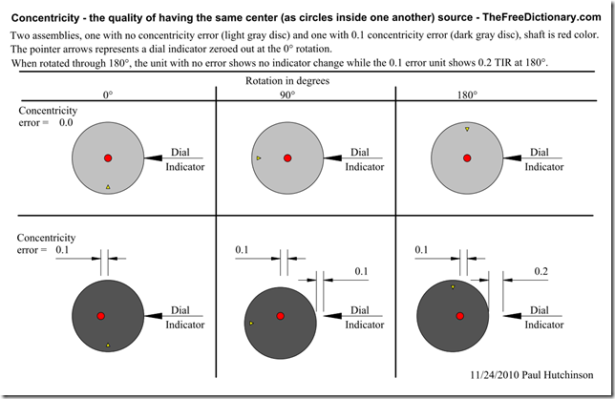](http://paulhutch.com/wordpress/wp-content/uploads/2010/11/ConcentricityVsTIRlg.png)