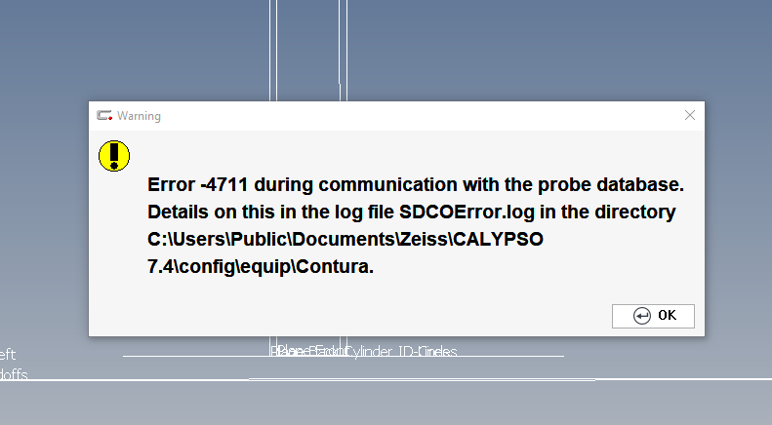

May 12, 2023 at 7:40:16 AM Error code: -4711

Exception while executing a query: UPDATE ports SET empty = 0 FROM component INNER JOIN ports ON component.rack = ports.port_ID WHERE (component.component_ID = '760bd1e5-7857-43b9-ad6f-f93e1dc24e72'); UPDATE component SET actual = 0 FROM component_usage AS component_usage_1 INNER JOIN component AS component_1 ON component_usage_1.component_ID = component_1.component_ID INNER JOIN component INNER JOIN component_usage ON component.component_ID = component_usage.component_ID ON component_usage_1.tool_ID = component_usage.tool_ID AND component_usage_1.buildorder <= component_usage.buildorder WHERE (component_1.component_ID = '760bd1e5-7857-43b9-ad6f-f93e1dc24e72'); UPDATE component SET mounted = 0 FROM component AS component_1 INNER JOIN component_usage ON component_1.component_ID = component_usage.component_ID INNER JOIN tool ON component_usage.tool_ID = tool.tool_ID INNER JOIN component_usage AS component_usage_1 ON tool.tool_ID = component_usage_1.tool_ID AND component_usage.buildorder <= component_usage_1.buildorder INNER JOIN component ON component_usage_1.component_ID = component.component_ID WHERE (component_1.component_ID = '760bd1e5-7857-43b9-ad6f-f93e1dc24e72'); UPDATE tool SET actual = 0; UPDATE tool SET mounted = 0 FROM component INNER JOIN component_usage ON component.component_ID = component_usage.component_ID INNER JOIN tool ON component_usage.tool_ID = tool.tool_ID WHERE (component.component_ID = '760bd1e5-7857-43b9-ad6f-f93e1dc24e72')--Execution Timeout Expired. The timeout period elapsed prior to completion of the operation or the server is not responding.

Operation cancelled by user.

The statement has been terminated. at Zeiss.IMT.MUMCPP.SDO.CZSQLCommand.ExecuteNonQuery()

at Zeiss.IMT.MUMCPP.SDO.SQLChangeObject.ConfirmAction(Int32 ChangeAction, Guid ComponentGuid)

at Zeiss.IMT.MUMCPP.SDO.SQLChangeObject.ConfirmChange()

at Heeg.SDOTCOProxy.Zeiss_IMT_MUMCPP_SDO_SQLChangeObject_ConfirmChange(SDOTCOProxy* , return_type* vwReturnValue, Int64 objectID)