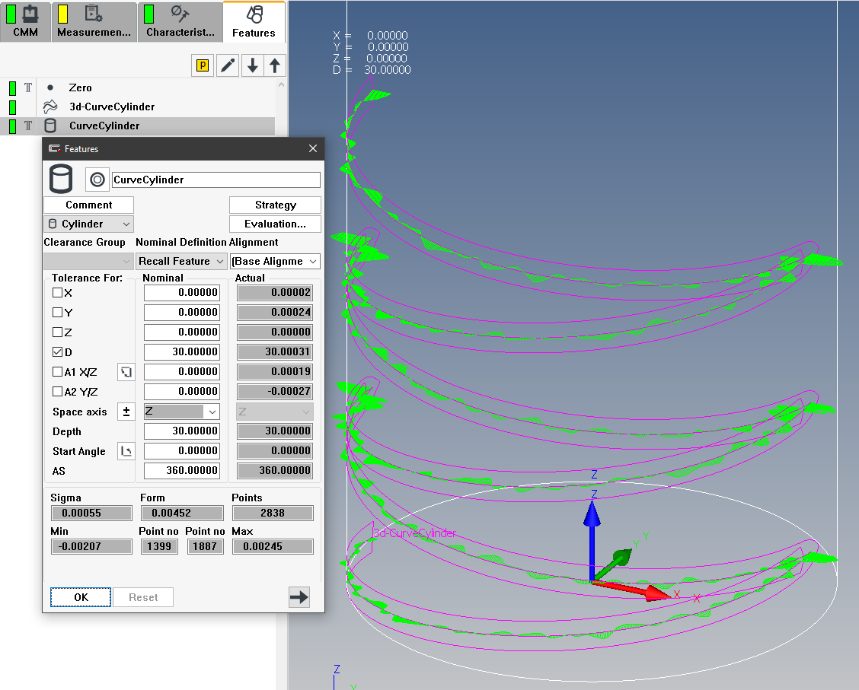

**PreSetting Inspection**

// Input

Diameter = 30.000

Lead = 10.000

StepAngle = 5.000

StartAngle = 180

SwitchAngle = 360

noTurns = 3

// Calculation

Radius = Diameter/2

Gradient = Lead/360

TotalAngle = 360*noTurns

// Special

Tab = chr(9)

deleteFile("c:\tmp\ZigZag.txt")

addToFile("c:\tmp\ZigZag.txt", "xNom yNom zNom uNom vNom wNom")

for i = StartAngle to (StartAngle + TotalAngle) step StepAngle

if (mod(i, 360) >= 180) and (mod(i, 360) <= 360)

j = i

else

j = 360-i

endif

//display(i, " " , j)

xV = round(Radius*cos(j), 6).asNumeralString

yV = round(Radius*sin(j), 6).asNumeralString

zV = round(Gradient*(-StartAngle + i), 6).asNumeralString

nx = round(cos(j), 6).asNumeralString

ny = round(sin(j), 6).asNumeralString

nz = "0.000000"

pt = xV+Tab+yV+Tab+zV+Tab+nx+Tab+ny+Tab+nz

addToFile("c:\tmp\ZigZag.txt", pt)

next i

noPtZigZag = i - 1