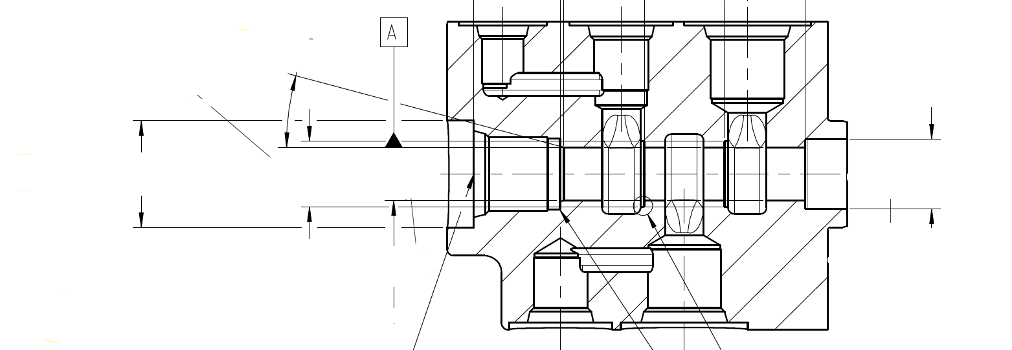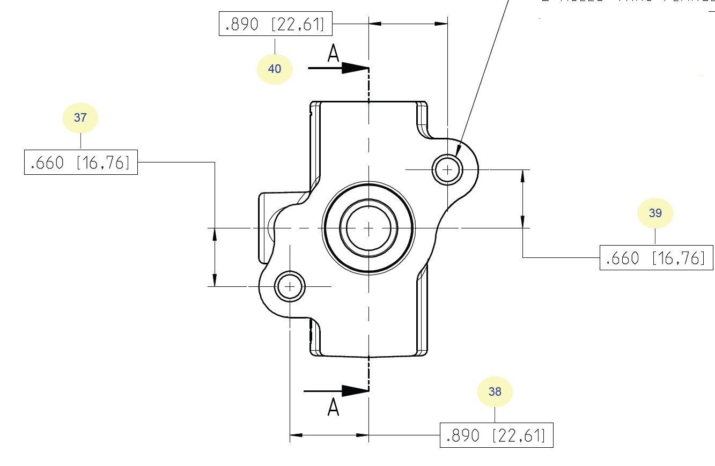

OK. For your alignment, use Datum A as the Spatial Rotation in the Y axis, and as the X & Z Origin. Your Y Origin can be that -Y Plane that you have listed as being used for your Z Origin.  
  
For your Planar Rotation you need something better, it can be a couple of things either that plane on the top of the part (if it is nice and machined), or you can use the hole to to the top right that you are evaluating its distances for. Now when you use the hole as your Planar you will see that it rotates the axis to be in line with it, if you want it to match your drawing, do this. While inside of the alignment, go to Special - click on Rotate by distances - I'm assuming the Spatial is the +Y, so select that on the Rotate around - and then the distances are the nominals of the hole, so in this case I have 0.89 for the Z, and 0.66 for the X for an angle of 36.5596. If your axis isn't lined up like your drawing, then you may just have to swap the numbers around and make one or both negative.

