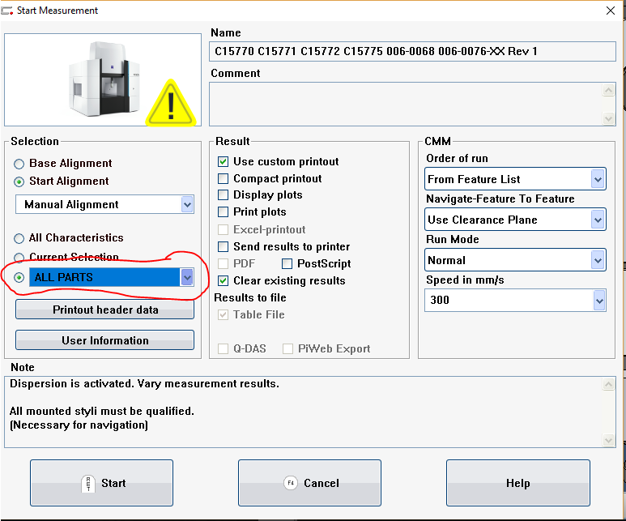

**I do have access to all of the programs thru the drop down.**