**To use no clearance plane**

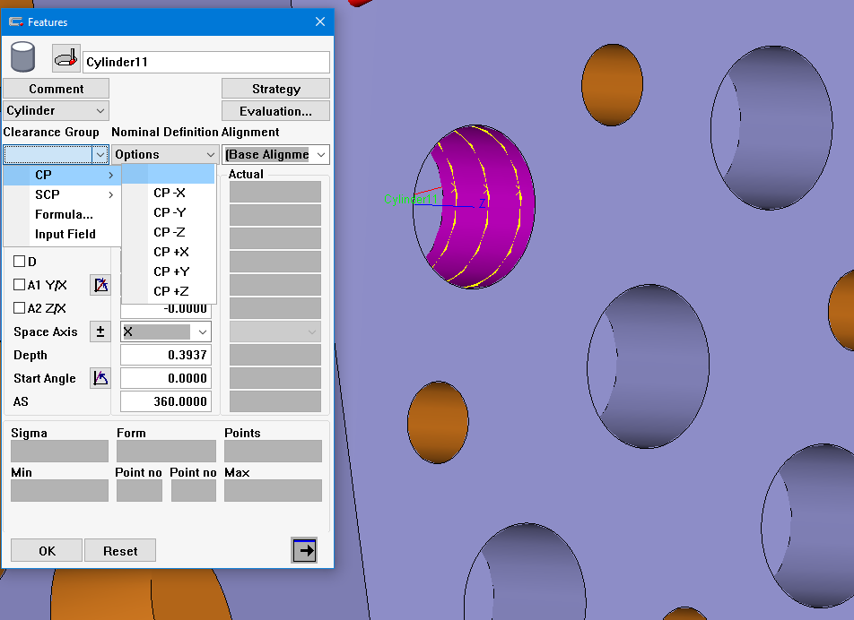

**Create a position point before and after measuring path**

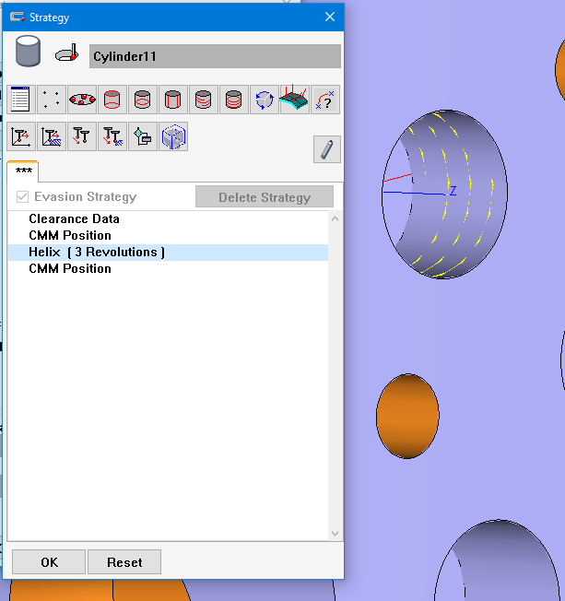

**Double click the CMM position within strategy. Set Coordinates Relative To “Feature”. Set Coordinate Representation to cartesian. Set XYZ all to zero. Determine whether X, Y, or Z aligns with the feature’s axis (In this example it is Z). Input a value that you believe would provide enough clearance for both position points. The position point creates an “X” in the CAD screen of where exactly it is located.**

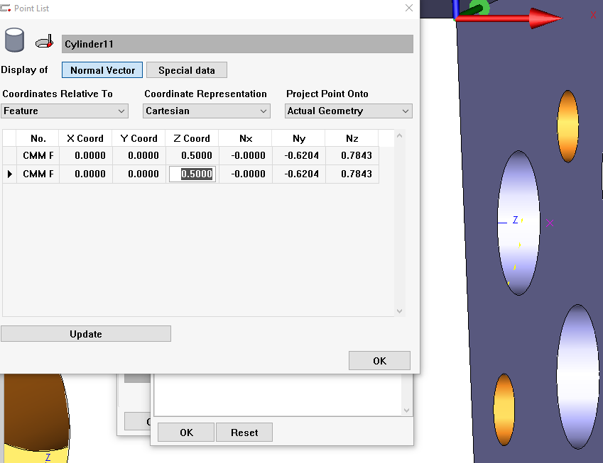

**When executed, the CMM should travel to the first position point, then carry out the measurement path, and then it will retract to the second position point. You can add whatever clearance you would want after this last position point.**