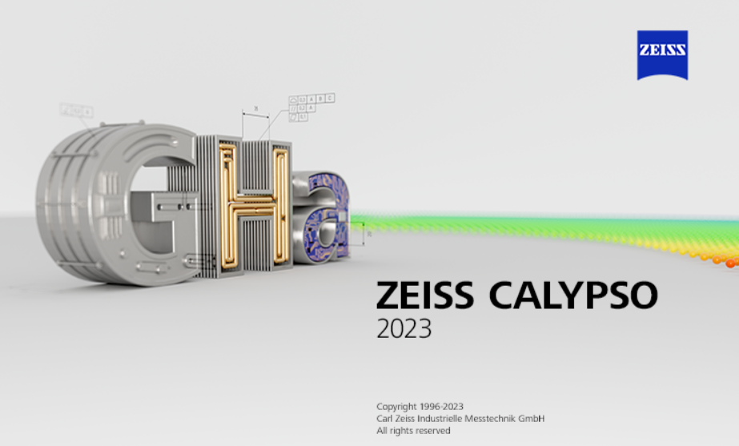 **Benefits of a SMA**

Calypso 2023 (7.6) is now available from Carl ZEISS

**Your investment in a Software Maintenance Agreement (SMA) fuels the development and improvement of your Calypso software. Every year a new version of Calypso is produced with powerful and useful updates to improve your measuring experience. Here are some of the newest additions to Calypso:**

* Calypso 7.6 is designed for Windows 10 IOT Enterprise 2021 LTSC Operating System.
* IMPROVED: Enhanced Toolbox functions for features and characteristics. Toolbox is bigger

and can be displayed on the side of the screen with more shortcuts.

* NEW: Shortcut button for Autorun on the home screen.
* NEW: Transparent CAD Model Function
* IMPROVED: Redesigned Traffic Light Interface Window.
* IMPROVED: PDF past reports can now be accessed through Pi-web. Allows easier access to your run history. Suitable replacement for MMC – Record Manager.
* ALSO AVAILABLE: GearPro (7.0), Pi-web Enterprise (8.4)
* IMPROVED: Reporting of plots is improved, such as Cylindricity plots and the True Position improved X/Y Plot.
* NEW: Calypso Online help menu has a makeover, new format and easier to navigate.
* NEW: Geber and Excellon Interface Option for PCBs. Use Existing tools to create features and characteristics or import groups from a file.
* IMPROVED: Optics functions, zoom in and out the camera image with the mouse, define search and location and a range for diameter size, adjust X and Y for each autofocus point. Many improvements to the Create Geometry Window.
* IMPROVED: Curves are now automatically calculated with a 3X measuring points to nominal. New mesh Best Fit for 2D curves.
* IMPROVED: Freeform Heat maps of deviations now show 4X faster. Any combination of degrees of freedom is now possible for fitting.
* IMPROVED: PCM commands that can create programs from PMI CADS and creating inspection plans from PMI. PCM commands added for converting units. PCM commands to retrieve individual point deviations from Curve and Freeform.
* NEW: BETA GD&T Engine providing new functions. New Option to define GD&T Standards ISO GPS and ASME Y14.5. Supports Common Datum Axis, Intersection Planes, Orientation Planes, Common circumferential profile tolerance zones. Tolerances for Material Condition now stored in the GD&T Object and so much more!

**\*Please note that C90 and C98 controlled systems may not be upgraded beyond Calypso 5.6**

**The development team from Carl ZEISS takes input from their user base very seriously. Please contact ZEISS with your ideas for improvements, or head over to our portal online to give them!** <https://portal.zeiss.com/my-voice>